FSI Membership Application
Form to fill in and undersign by aspirant members of the
Floriculture Sustainability Initiative

Outlining the application process and the guidelines for acceptance of membership.

1. Application

An organization that applies for FSI membership submits the following to the FSI Secretariat:
  - Completed application form, including initialed membership rules, fees and code of conduct. And has taken notice of the FSI Articles of Association as published on the FSI website.
  - Description of the organization, incl. mission statement, goals, relationship to the floriculture sector.
  - Motivation to join FSI.

- Admission

- The FSI Secretariat presents the application to the FSI Board. The Board may ask for additional information about the applicant.
- The Board will vote whether to approve membership.
- The FSI Board can reject a membership application if the applicant has neither demonstrated a perceptible commitment to a sustainable floriculture sector nor a valid stakeholder interest in the objectives of FSI, or if any social, environmental or legal grievances are found.

- Membership
    - The FSI secretariat will inform the applicant of their acceptance or rejection one week after a board decision.
    - The FSI secretariat calculates the membership fee and only when the membership fee is received, the applicant is considered a member, and the organization can communicate about their FSI membership.
    - Approved applicants will be added to the FSI members’ directory on the FSI website and welcomed through a Linked-In post
    - Members will be sent the FSI logo for display on their website once payment has been received.

Page 1 FSI Membership Application – 2026
Application Form
PART 1 – General information
Organization name: | Click or tap here to enter text.
Type of organization:
Type of organization: | Click or tap here to enter text.
Contact person: | Click or tap here to enter text.
Position: | Click or tap here to enter text. | Official Address: |  |  | Click or tap here to enter text.
Email: |  | Postal code:
Email: | Click or tap here to enter text. |  |  |  | Click or tap here to enter text.
Telephone: |  | Country:
Telephone: | Click or tap here to enter text. |  |  |  | Click or tap here to enter text.
Website:
Website: | Click or tap here to enter text.
Hereby applies to become member of FSI:
There are two kinds of memberships at FSI:
Ordinary members are companies directly involved in the supply chain; and associations, organizations, foundations, federations, or confederations active in the floriculture sector, falling into one of the following stakeholder groups. Ordinary members have voting rights at the General Assembly.
Associate membership is open and accessible to all other stakeholders and Industry members in the floriculture sector who do not meet the criteria to be eligible as Ordinary member. Associate members do not have voting rights.
Stakeholder group: | ☐Production Global North | ☐Standard/Certification Scheme
 | ☐Production Africa  ☐Production Latam  ☐Trade/Wholesale  ☐Retail | ☐Civil Society Organization  ☐Associate member
Page 2 FSI Membership Application – 2026
Membership Rules
- Membership categories
  - FSI membership is open to profit and not-for-profit organizations that are a stakeholder in the international floricultural sector.
  - Each Member organization shall appoint one or more natural persons to represent it within FSI. One person shall be identified as main contact for all formal correspondence with FSI.

- Rights of FSI members
  - Ordinary members are entitled to vote in the General Assembly meetings. They can be elected for a seat in the Board and can be invited by the FSI Board to participate in one or more Working Groups.
  - Associate and industry members are observing members and can be invited by the FSI Board to participate in one of the Working groups
  - All members are encouraged to take part in the General Assembly meetings and engage in the discussion with FSI throughout the year.
  - All FSI members will be informed about the activities of FSI and its members through the FSI secretariat.

- Duties of FSI members:
- For all FSI members:

  - Commit to the vision and ambitions of FSI and actively work towards the objectives and support the FSI strategy.
  - Commit, use and adhere to the FSI Code of Conduct for floriculture.
  - Actively share information and interact within their supply chain and network, to increase their and the industry’s achievements towards FSI objectives.
  - Pay their membership fee in time.
  - Represent their respective organization and become ambassadors of FSI.
  - Promote and communicate their commitment throughout their own organization and to their customers, suppliers, subcontractors and other relevant actors of the supply chain from production to consumption.
- For FSI members producing, trading and/or retailing flowers and plants:

  - They will report according to the FSI monitoring protocol and provide a yearly Action Plan with their production/procurement objectives to FSI for review, guidance and support.
  - Report in Q1 of every year to the FSI Secretariat the sourced or traded volumes of flowers and plants of the previous year, and actions taken to reach 100% FSI-Compliant sourcing. Reported volumes need to be verified through the members internal/external accountant.
  - The members of trade and retail, when they source directly from growers, are required to report via the Floridata Sustainable Sourcing Scan. The members will contact Floridata for admissions and will pay the applicable fee. https://sustainablesourcingscan.eu/en/
  - They fill in their status/progress regarding additional topics that will be included in the narrative part of reporting.
Page 3 FSI Membership Application – 2026

- Membership fees
  - The FSI Board reviews the amount, scaling method of membership fees on an annual basis and submits the proposal to the General Assembly for approval.
  - The annual membership fee will be invoiced at the beginning of each calendar year.
  - FSI membership fees are based on the category, size or annual turnover of the organization:
  - Membership fees must be paid at the latest 15 days after receiving the invoice.
  - Members joining FSI part way through a financial year shall pay the amount of membership fees as calculated for their membership category on a pro rata basis.
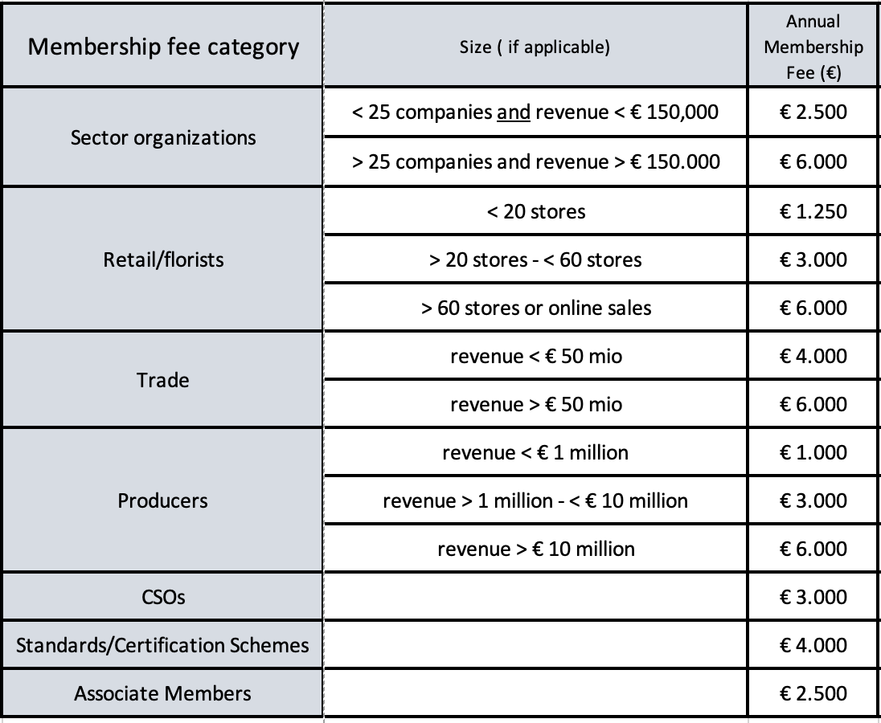

- Termination of membership and re-admission
  - Membership terminates by:
  - Voluntary withdrawal. Possible any time via written notice of resignation to the FSI secretariat. No reimbursement of membership fee.
  - Exclusion from FSI after not fulfilling the FSI membership duties by the FSI Board. No reimbursement of membership fee.
  - Failing to pay the membership fee in time.
  - Dissolution of the member organization.
  - Re-entry into FSI is possible if the respective reasons for termination of the membership are no longer valid. Readmission is possible at the discretion of the FSI Board without having to complete the application procedure for new members.
Page 4 FSI Membership Application – 2026

FSI Strategy and Ambition

The FSI strategy builds upon the foundation of the FSI “Transparent and Responsible supply chain” strategy and results, and the transition towards the 2030 strategy, incorporating sectoral and sustainability trends as well as upcoming regulations. These elements serve as key anchors to guide FSI's evolution and establish a strong, long-term vision and clear actions for 2030 and beyond
FSI’s ambition is to help future-proof the floriculture sector through supporting sustainable practices that benefit people, nature and society. The FSI members collaborate on 3 spaces of action:
- Facilitate 100% FSI-Compliant products
Ensure adherence to sector standards and certifications as a foundation for sustainable operations and a license to operate.
- Enhance the use of new tools and resources
Integrated cutting edge tools and resources to develop innovative solutions to drive informed decision making and accountability.
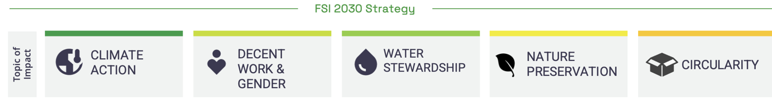
- Boost data-insights & collaboration
Strengthen partnerships and foster an ecosystem of shared learning across the sector. Empower the industry with clear, impactful narratives that highlight progress, challenges, and achievements.

FSI takes an agile approach to its 2030 strategy to deliver on the above 5 topics of impact, allowing flexibility to adjust targets and prioritise topics based on urgency and relevance. Progress will be guided by milestones, ensuring a clear scope and definition of achievements. Action plans and reporting timelines are staggered, enabling balanced and effective implementation over the five-year period.

Describe what you can bring to the FSI ambition and objectives
Click or tap here to enter text.

Describe what are your expectations as FSI member and how you will benefit from your membership
Click or tap here to enter text.

Page 5 FSI Membership Application – 2026

OBJECTIVES:
FSI members are encouraged to support transformation and develop best practices through projects and business cases. Please explain how your organization could contribute and if applicable, describe the key topics(s) you would like to contribute?
Describe your sustainability project idea(s) & potential partnerships
Click or tap here to enter text.

Please indicate which sustainability theme(s) and regions your organization is keen to focus on:

TOPIC | REGION
Click or tap here to enter text. | Click or tap here to enter text.
Click or tap here to enter text. | Click or tap here to enter text.
Click or tap here to enter text. | Click or tap here to enter text.

Page 6 FSI Membership Application – 2026

SIGNATURE PAGE

In applying for FSI membership, our organization agrees to:
  - abide by the Articles of Associations, as published on the FSI website,
  - commit to the FSI Code of Conduct, as published on the FSI website
  - commit to the ambitions and objectives of FSI, including compliance with the FSI Basket of Standards and reporting of sustainable volumes if applicable.

By signing the application form I confirm that I have read and understood the Application Procedure and the FSI Membership Rules.

For (your organization): | Click or tap here to enter text.
Name: | Click or tap here to enter text.
Position: | Click or tap here to enter text.
Date: | Click or tap here to enter text.
Signature:

Page 7 FSI Membership Application – 2026

